# Usability Heuristics for UI Design

A heuristic evaluation is a way to test whether a website is user-friendly *(test its usability)*.

Unlike user testing – the site/prototype is evaluated by users, a heuristic evaluation is evaluated by usability experts. That is why it can also be referred to as an “expert review.”

A heuristic evaluation (expert review) of a web/mobile site is based on a set of predetermined heuristics or qualitative guidelines. Here are some broad heuristics:

* Visibility of system status
  + **Keep users informed about what is going on**, using appropriate feedback within a reasonable time
* Match between system and real world
  + **Show information in ways users understand** from how the real world operates, and in the users’ language
* User control and freedom
  + **Offer users control** and let them undo errors easily
* Consistency and standards
  + **Be consistent** so users aren’t confused over what different words, icons (etc.) mean
* Error prevention
  + **Prevent errors**, as a system should either:
    - Avoid conditions where errors arise
    - Warn users before they take risk actions (e.g. “Are you sure you want to do this?” messages)
* Recognition rather than recall
  + **Have visible information/instructions, etc., to let users recognise options/actions, etc.,** instead of forcing users to rely on memory
* Flexiblity and efficiency of use
  + **Be flexible** so experienced users find faster ways to attain goals
* Aesthetic and minimalist design
  + **Have no clutter**, containing only relvant information for current tasks
* Helps users recognise, diagnose and recover from errors
  + **Provide plain-language help** regarding errors and solutions
* Help and documentation
  + **List concise steps in lean and searchable documentation** for overcoming problems

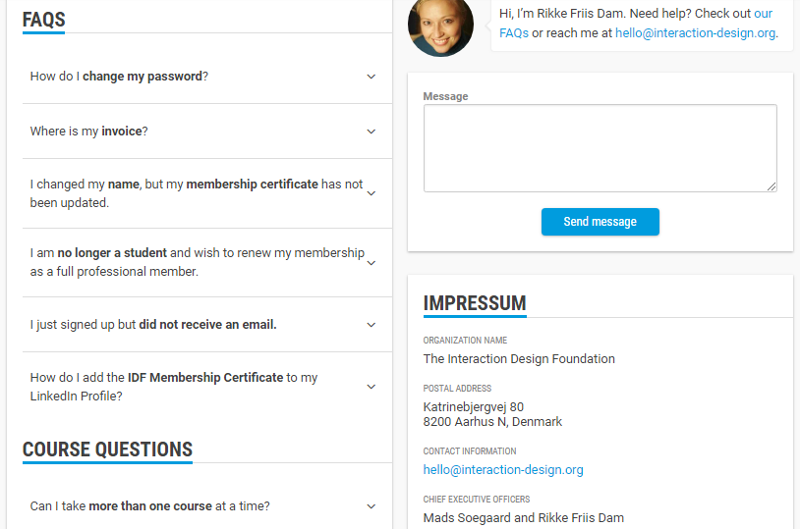(interaction-design.org Contact Page)

|  |  |
| --- | --- |
| Pro’s | Con’s |
| Evaluators can focus directly on specific issues | Evaluators may bring up issues, that aren’t usability problems |
| Evaluators can pinpoint faults with individual elements early on, and determine their impact on overall UX | One has to choose exactly the right heuristics (and a number of them) to make sure evaluators find all usability issues |
| Compared with user testing, one can get feedback without the ethical and practical dimensions and costs | It can be expensive/hard to find evaluators who are experts in a certain industry or usability |
| You can combine it with usability testing | As a number of expert evaluators are required, one may find it easier to stick to usability testing (also cheaper) |
| With the right heuristics, evaluators can flag up detailed issues and lead the way to optimal solutions | It’s subjective. Findings can lack proof and can be biased. |

## How To Conduct a Heuristic Evaluation

* Know what to test and how
  + Whether its an entire product/procedure, clearly define the parameters of what to test and the objective
* Know your users (have clear definitions of your target audience)
  + User personas can help evaluators see things from the users’ perspectives
* Select 3 to 5 evaluators
  + Ensuring their expertise in usability and relevant industry experience
* Define the heuristics
  + This will depend on the nature of the system/product/design
* Brief evaluators on what to cover
  + Suggesting a selection of tasks to find issues
* 1st Walkthrough
  + Have Evaluators use the product freely, so they can identify the elements to analyse
* 2nd Walkthrough
  + Evaluators scrutinise individual elements, according to the heuristics. They can also examine how these fit into the overall design, clearly recording all the issues that are encountered
* Debrief the evaluators
  + In a session, debrief them in order for them to collate results for analysis and suggest solutions

Note: For a quick application evaluation, 5 seconds is long enough for a good design to communicate its primary message. As there is a growing trend for website visitors to open many sites at once, reducing the attention each receives and increasing the importance of effective design and messaging.

## Five Quick Questions when doing an Application Evaluation

* What is the purpose of the page?
* What are the main elements you can recall?
* Who do you think the intended audience is?
* Did the design or brand appear trustworthy?
* What was your impression of the design?